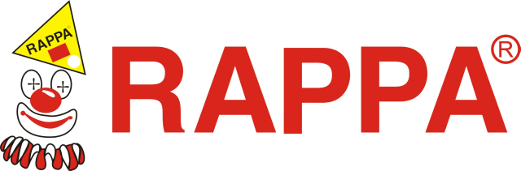

|  |
| --- |
| phone: +420 596 927 161 ext. 40, +420 608 270 809, fax: +420 596 914 797 |

Withdrawal from the contract by the consumer within 30 days of receipt of gooDS

You can return the purchased goods under the Civil Code without giving any reason within 30 days of taking over. In that case, the amount you paid for the goods will be returned to you in accordance with the Purchase and Claim Rules. Goods can be returned under the following conditions:

* **Goods will be unused and undamaged**
* **Goods will be in its original packaging**
* **The goods will be sent back together with all the proofs of purchase to our address**
* **The return of goods is not excluded by law**

Shipments that will be sent back for cash on delivery will not be accepted by us for understandable reasons.

Fill out this form and send it back only if you want to withdraw from the contract.

**Recipient (Seller):** Rappa s.r.o., Za Humny 1082/1, 725 25 Ostrava - Polanka

**Customer (Buyer):**

Name and surname: ……………………………………………………………………………………..

Address: ………………………………………………………………………………………………….

Phone: ……………………………. E-mail: ………………………………………….............

Purchase price to be returned:

*by wire transfer to bank account number: …………………………………………

*by another way: ………………….....…………………………………………………………

**Returned goods (Name, article number):** ……………………………………………………………………

……………………………………………………………………………………………………………

……………………………………………………………………………………………………………

Sales document number**:**…………………………… Date of sale: ……………………………

…………………………………………….

**Date and signature of customer (buyer)**

**\* Delete as appropriate**